**Developer’s Guide:**

**Required Softwares**:

* NodeJs 16 or above.
* SQL Server Management Studio 19.
* Visual Studio 2022, Visual Studio Code.
* Download source code via link: [*https://github.com/Dustin9x/BusOnlineTicket*](https://github.com/Dustin9x/BusOnlineTicket)

**Import database:**

* Extract the downloaded file.
* Run SQL Server Management Studio and import database from folder Database/busonlineticket.sql

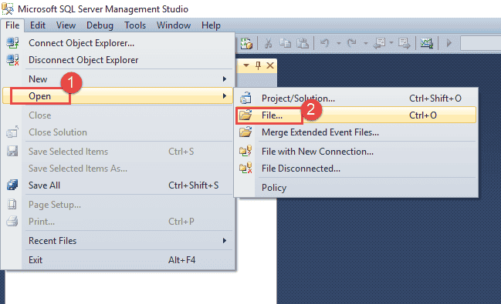

**Run backend:**

* Open folder backend and run file *backend.sln* to run the program by Visual Studio 2022.

* Change your ConnectionStrings in appsetting.json file, with your own information, see below example:



* Hit run button have green color to start the backend server:A screenshot of a computer

  Description automatically generated

CLICK IT TO RUN

* Check the package version if it’s necessary

**Run frontend:**

* Open folder Fontend by command prompt:

* Run command: npm install. Please be patience, it will take about 5 minutes to start the frontend server.
* If it’s not work. Try: npm install –force
* After the installing project is finished. Then npm start.
* And finally: Enjoy your time with PHTVBUS 😊

**Website interface:**

**Demo account:**

* Admin:
  + Email: admin@phtv.com
  + Password: admin
* Moderator:
  + Email: emp@phtv.com
  + Password: mod123
* Customer:
  + Email: user@phtv.com
  + Password: user123
* Driver:
  + Email: driver1@phtv.com
  + Password: driver1@phtv.com

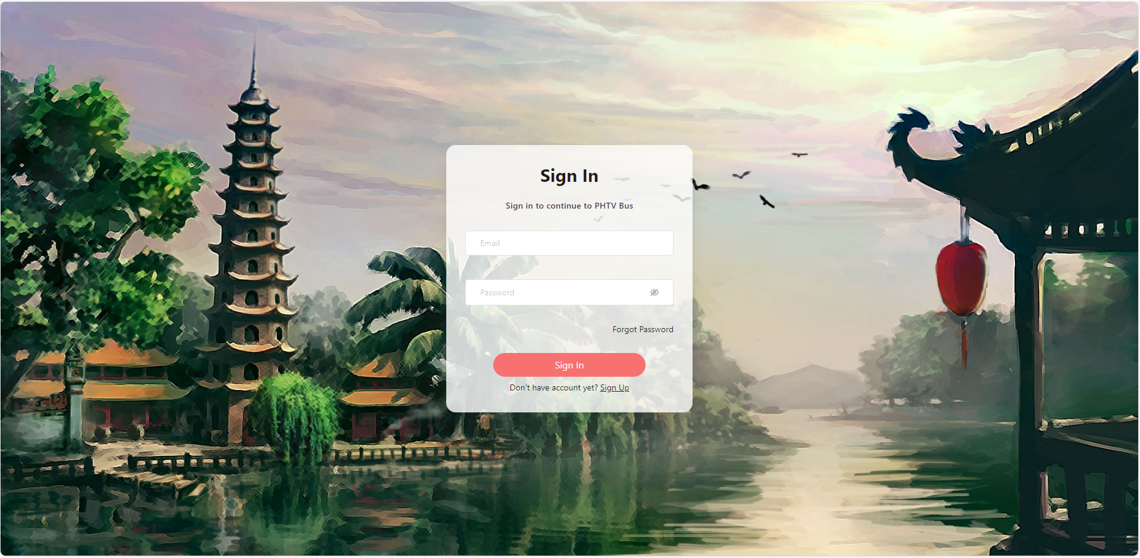

**Demo bank account:**

* Card number: any number
* Card holder name: any name
* OTP: 123456

